What’s Going on in SMHS English Classes – 1st Quarter
READING INTERVENTIONS CLASSES (Greg B.: freshman; Jessica B. 10-12)
- Combo of
  - Read180 (freshman only)
  - Achieve3000
  - Supporting regular English class coursework (AR goals, major summatives)
  - Work sample mop-up
FRESHMAN PLC
- PLC Members: Jen McKenzie, Kalin Cross, Greg Bryant, Jessica Bangma, Caroline Campbell

Quarter 1 | Formative/Summative
Theme: Identity  Common Text:  The House on Mango Street, Honors: I Know Why the Caged Bird Sings  Priority Standards / Learning Targets:  9.RL.3 Analyze how complex characters develop over the course of a text, interact with other characters, and advance the plot or develop the theme.  - Target(s): I can identify and explain the role of complex characters in a text, analyze how they develop over the course of a text, develop through their interactions with others and advance the plot of a text/ contribute to the development of the theme. (R)  9.W.3: Write narratives to develop real or imagined experience or events using effective technique, well-chosen details, and well-structured event sequences.  - Target(s): I can define narrative and describe the basic parts of the plot (exposition, rising action, climax, falling action and resolution). (K)  - Target(s): I can write a narrative using appropriate techniques (dialogue, pacing, description, reflection, and/or multiple plot lines). (P)  9.SL.4: Present information, findings, and supporting evidence clearly, concisely and logically such that listeners can follow the line of reasoning and the organization, development, substance and style are appropriate to purpose, audience, and task.  - Target(s): I can present information, findings, and/ or supporting evidence clearly, concisely, and logically in a sequence that allows the listeners to follow my line of reasoning. (P)  9.L.2: Demonstrate command of the conventions of standard English, capitalization, punctuation, and spelling when writing.  - Target(s): I can use correct capitalization, semi-colons and colons; I can spell correctly. (S)  9.L.5: Demonstrate understanding of figurative language, word relationships and nuances in word meanings.  - Target(s): I can define and identify various forms of figurative language (e.g., simile, metaphor, hyperbole, personification, alliteration, onomatopoeia.) (K)  - Target(s): I can use figurative language in my narrative writing language (e.g., simile, metaphor, hyperbole, personification, alliteration, onomatopoeia.) (S)  Common Assessment / Work Samples /* LPA:  · SRI- Lexile  · Paragraph Write (SMHS Rubric)  · Baseline 5-Paragraph Write (Narrative LPA Rubric)  · AR Assessment  · Literary Reading Work Sample - Literary Elements Assessment | 9.RL.3  - Mango Comprehension/Analysis Quizes – Timed Writes (F)  - Literary Reading Work Sample (S)  9.W.3  -Story Label Quiz (F)  - Paragraph Writes (F)  -Baseline 5-paragraph Write (F)  -Personal Narrative LPA (S)  9.SL.4  -Reading Strategy Bookmarks (F)  -AR Book talks (F)  - End of the Quarter AR Book talk (S)  9.L.2  -Collections GrammarNotes Lessons (F)  - Grammar Assessment (S)  -Baseline 5-paragraph Write (F)  -Personal Narrative LPA (S)  9.L.5  -Figurative Language Pre/Post Assessment (F/S)  - Mango Comprehension/Analysis Quizes (F)  - Literary Reading Work Sample (S)

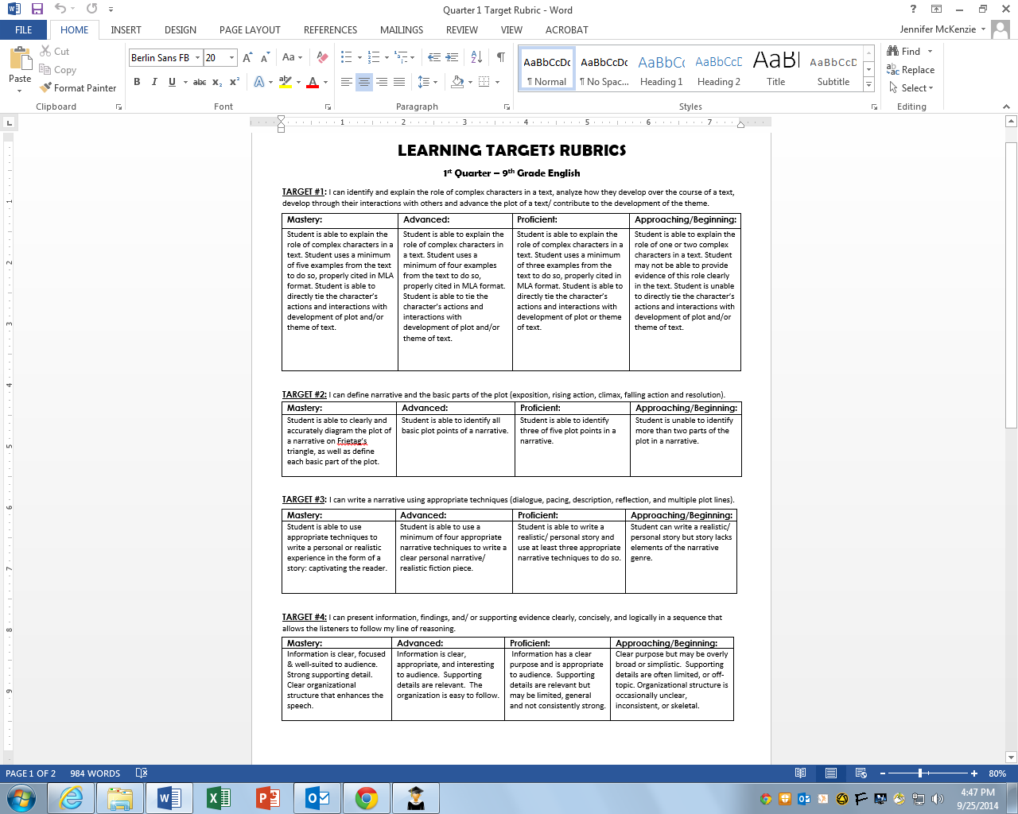
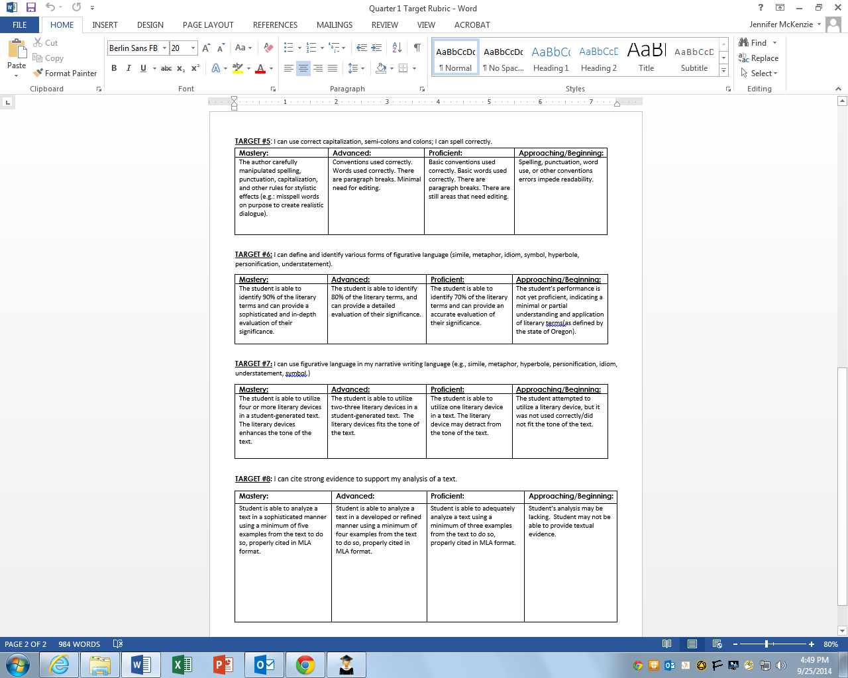

First Quarter Planner 2014-2015
10 min Library Visit – once a week

ABC Dates
September  3, 4, 5 | Lesson 1  Syllabus, behavior. Set up learning journals. Check out Collections. Infused Honors. Baseline narrative. | Lesson 2  Lib Orientation
8, 9, 10 | Lesson 3  Lab – type baseline narrative (“The First Time”), Google Docs | Lesson 4  Lab – finish typing baseline narrative (“The First Time”), Google Docs, Turn It In
11, 12, 13 | Lesson 5  Read Where the Wild Things Are - library to AR test  Class Photos for Open House | Lesson 6  Fig Lang & Lit terms Pre-Assessment: Plot - (exposition, rising action, climax, falling action, resolution)  Conventions Pre-Assessment  Check out Mango / Mango intro: video trailer-make predictions,  Ch 1-6, wkst
16, 17, 18 | Lesson 7  SRI | Lesson 8 (Read)  Intro Socratic Seminar / practice session - discuss Ch 1-6  Assign Ch 7-14
19, 22, 23 | Lesson 9 (Speak)  Figurative Language slides  Assign Booktalk  Socratic Seminar - formative | Lesson 10 (Write)  Comma slides and assessment (Collections)  Timed Write Mango Ch 7-14/pg. 32
24, 25, 26 | Lesson 11  Comma homework check  Finish Timed Write Mango Ch 7-14/pg. 32  Personal narrative/realistic fiction calibration | Lesson 12  Heart map  Read Mango – Ch 15-22 / Socratic Seminar prep  Fig Lang / Plot review
October  29, 30, 1 | Lesson 13  Socratic Seminar Mango 15-22  Socratic Seminar - Jeanne Rasmussen/mentee visiting | Lesson 14  Begin Narrative: “The Time I Got In Trouble” (plot), warm up  Fig Lang / Plot Quiz  Mango - pgs. 58-83/seminar prep
Mid Quarter  2, 3, 6 | Lesson 15  Booktalk/poster examples  Socratic Seminar Mango 23-32, pgs. 58-83 | Lesson 16  Cherished Object quick write (5 senses, blankie :)  Mango Timed write #2  Finish Mango 84-110 (comprehension test next class)
7, 8, 9 | Lesson 17  Mango comprehension test (AR test)  Narrative Leads & Meaningful endings  minder – one-pager due!) | Lesson 18  Mango test  Dialogue  In-class draft LPA
10, 13, 14  (PSAT 10/15) | Lesson 19 (Warm Up: commas & conjunctions/comma splice)  Lab Day 1 | Lesson 20 (Warm Up: spell numbers smaller than 10, semicolons)  Lab Day 2
16, 17, 20 | Lesson 21 (Warm Up: compund sentences and backwards revise)  Lab Day 3 | Lesson 22  Lab Day 4 - Finish / Print
21, 22, 23 | Lesson 23  Pod Grade paper copies in class  (make up essays on Chromers!) | Lesson 24  One-Pager / Book Talk (formative - pod grade and record with iPads)
24, 27, 28 | Lesson 25  RWS - Speak | Lesson 26  RWS - Speak  Q1 Self-Evaluation
29, 30, 31 | Lesson 27  Socratic Seminar - Speak RWS  Socratic Seminar - Jeanne R. & Peggy S./mentees visiting | Lesson 28  Set up student data folders  Review Turnitin.com feedback / correct errors (conventions make up for students who are failing because of SF/C on narrative essay)  Comma Post-assessment

SOPHOMORE PLC
- PLC Members: Hector Santiago, Camille Schuler, Jenny Tyrrell, Rachel Allred (also teaches AP prep class), Emily Marshall
- Collection: One
- Common Texts: Goldfish, Wife’s Story, Texas v. Johnson & Flag Editorial
- Common Summatives: Analysis Essay (argumentative writing work sample & performance task B), vocab final (**Common Assessments)
- Common Formatives: Pretest “The Bike”/Soto analysis, Pretest on academic vocabulary, Analysis Paragraph on Goldfish, Analysis Paragraph on Wife’s Story, Comparative Timed Write Flag Texts (**Common Assessments)

Targets | Baseline Data | Formative Assessments  **common | Summative Assessments  **common | Extend/ Reteach  *level ups?  *grammarNotes? | Data for Analysis/ Comparison
ENG 2/AP PREP: I can use TADPOLE as a tool to identify author’s choices. | **“The Jacket” pretest | TADPOLE worksheet | **Vocab Final
ENG 2/ AP PREP: I can analyze how an author’s choices (tone, POV, diction, imagery) create a certain effect (mystery, tension, surprise). | **“The Jacket” pretest | **Goldfish Paragraph  **Wife’s Story Paragraph | **Comparative Timed Write Flag Texts
ENG 2/AP PREP: I can determine a theme of a text and analyze how it is shaped and refined by specific details. | **“The Jacket” pretest |  | **Analysis Essay (argument WS)
ENG 2/AP PREP: I can write an essay with a clear thesis statement and analysis based on textual evidence, while avoiding plot summary. |  | Paragraph writes | **Analysis Essay (argument WS)
ENG 2: I can write a paragraph with a clear topic sentence, analysis based on textual evidence, and a conclusion that reflects that topic, while avoiding plot summary. | **“The Jacket” pretest | **Goldfish Paragraph  **Wife’s Story Paragraph | **Comparative Timed Write Flag Texts
AP PREP: (TKAM) I can explain how multiple motivations create complex characters in a text and analyze how authors use complex characters to emphasize a particular theme. |  | 3 Timed Writes | Final Essay
AP PREP: (AR) I can select, read and comprehend college level books. | Lexiles | Summer Reading AR  TKAM AR | Overall AR total
Eng 2/AP PREP: I can identify and correct sentence fragments, run-on sentences and comma splices. | **“The Jacket” pretest | **Goldfish Paragraph  **Wife’s Story Paragraph | **Comparative Timed Write Flag Texts  **Analysis Essay (argument WS) | GrammarNotes Lessons 1, 2, 3, 20
Eng 2/AP PREP: I can avoid first & second person POV in my academic writing (you). | **“The Jacket” pretest | **Goldfish Paragraph | **Comparative Timed Write Flag Texts  **Analysis Essay (argument WS)
ENG 2/ AP PREP: I can define and apply the terms from the academic vocabulary list. | **Pretest (Quizzle?) |  | **Final Exam
Eng 2: I can read a book within the AR system and explain details of character developments and overall plot contained in the story | Lexiles

ENG 2 Academic Vocab: TADPOLE, analysis, inference, theme, claim, textual evidence, commentary, tone, diction, 1st/2nd/3rd person point of view, connotation, denotation, symbolism, metaphor, simile, personification, run-on, fragment, comma splice
AP PREP Academic Vocab: (list above plus:) 3rd person omniscient point of view, 3rd person limited point of view, syntax, juxtaposition, synecdoche, context, dependent clause, independent clause Tone Words: (20 from list)
Collections Specific Vocab: discriminate, diverse, inhibit, intervene, rational GOLDFISH: poignant, wizened, beleaguered, fluent FLAG BURNING: seminal document, compulsion, implicit, reaffirmation, resilience, orthodoxy, sanctity, dissenters, dogma THE LOTTERY: profusely, perfunctory, petulantly, defiantly

JUNIOR PLC
PLC Members: Joann Schaeffer, Adam Drew, Rebecca Read (Jenny T. also teaches 1 section of English 3)
Collection Three: The Individual and Society

Targets | Baseline Data | Formative Assessments | Summative Assessments  *note work samples where applicable | Extend/ Reteach  *level ups?  *grammarNotes? | Data for Analysis/ Comparison
I can cite textual evidence and determine themes of a text. | This I Believe Prompts and Example Essays | Journals  Close Reading  Chosen texts whole class exercises around text evidence and theme. | Collections:  Whitman’s “Song of Myself”  Close Reader: pages 37-42 | Added intensity and contrast with Hughes “I Too Hear America Sing” | Analyzing theme and incorporating textual evidence worksheet for chosen essays.  This I Believe Essay Writing Guide
I can analyze how an author’s choices concerning how to structure specific parts of a text contribute to its overall meaning as well as its aesthetic impact. | Small group discussions around structure. | Socratic Seminar  Practice exercise with chosen texts: Malcolm X’s “Coming to an Awareness of Language” and Sherman Alexie’s “Joys of Reading and Writing: Superman and Me” | Collections short stories/texts:  “Self-Reliance”  “The Minister’s Black Veil”  “The Pit and the Pendulum” | Adding  DRAPES Research to our Narrative Writing:  Dialogue  Rhetorical Questions  Anecdotes  Personal Experience  Examples  Statistics | This I Believe Essay/ Narrative and Synthesis
I can interpret figures of speech, figurative language and literary details. | Pretest after taking class notes on figures of speech, figurative language and literary details. | Pretest for figures of speech, figurative language and literary details | Emily Dickinson: “Tell the Truth but Tell it Slant”  and  “Much Madness is Divinest Sense” | Level up/grammar notes in Collections Teacher worksheets | Figurative language, figures of speech, literary details pre-tests and worksheets.
I can analyze a case in which grasping point of view requires distinguishing what is directly stated in a text from what is really meant. | What does it say, what does it mean debate. | Close Reading Activity  Journals for Socratic Seminar  Analysis Debates:  Theme: The Individual and Society  Technology  and School/Standards and Expectations | Synthesis Essay on Socratic Seminar  Theme: The Individual and Society | Office hours level up group sessions.  Struggling student office hours group sessions  Class reviews | Close Reading assignments and anchor text assignments
I can read and comprehend a piece of literature | OAKS Score  Lexile Level |  | AR Test | Lexile challenge or encourage students to read higher lexile level or more challenging books.

SENIOR PLC
PLC Members: Emily Marshall, Kelly Burton, Leslie Davis
Collection: 1
Targets | Baseline Data | Formative Assessments | Summative Assessments  *note work samples where applicable | Teach/Extend/ Reteach  *level ups?  *grammarNotes? | Data for Analysis/ Comparison
Writing (Ideas and Content): I can write a college essay that focuses on narrative techniques with strong ideas and relevant supporting details. | Descriptive paragraph  College/Narrative Essay #1; choose from 3 prompts; 350 words | Descriptive paragraph  College/Narrative Essay #1; choose from 3 prompts; 350 words  Texts: Grit videos, MLK Blueprint Article | Narrative/College Essay #2 | Character development visualization  Brainstorming and journal prompts  Strong 1st person voice  Revise and edit | College Essay #2
Writing (Organization): I can organize a college essay that includes narrative structure: compelling introduction, organized body paragraphs, appropriate transitions, and insightful conclusion. | Descriptive paragraph  College/Narrative Essay #1; choose from 3 prompts; 350 words | • Descriptive paragraph  • College/Narrative Essay #1; choose from 3 prompts; 350 words | Narrative/College Essay #2 | Paragraph structure: topic sentence, concrete details, analysis, concluding sentence.  Story structure  Effective transitions and transition statements  Revise and edit | College Essay #2
Writing (Conventions): I can demonstrate control of standard writing conventions in punctuation, spelling, and capitalization. | Descriptive paragraph  College/Narrative Essay #1; choose from 3 prompts; 350 words | • Descriptive paragraph  • College/Narrative Essay #1; choose from 3 prompts; 350 words | Narrative/College Essay #2 | Dialogue  Comma splices  Punctuation: commas, dashes, semi-colons, colons, ellipsis,  Revise and edit | College Essay #2
Writing (Sentence Fluency): I can vary sentence length and demonstrate consistent control over: simple, complex, and compound sentence structures. | Descriptive paragraph  College/Narrative Essay #1; choose from 3 prompts; 350 words | Descriptive paragraph  College/Narrative Essay #1; choose from 3 prompts; 350 words | Narrative/College Essay #2 | Simple, compound, and complex sentences.  Fragments, subjects and predicates  Sentence frames  Revise and edit | Narrative/College Essay #2
Writing (formatting): I can format my writing according to MLA standards with appropriate spacing, heading, title, margins, font, etc. | Descriptive paragraph  College/Narrative Essay #1; choose from 3 prompts; 350 words | Descriptive paragraph  College/Narrative Essay #1; choose from 3 prompts; 350 words | Narrative/College Essay #2 | How to insert header procedures  Proper spacing on paragraphs  Organization  All things formatting  Revise and edit | Narrative/College Essay #2
Reading Info Text (analyze): I can analyze the structure of an argument and use evidence to create my own claims. | Pre-test: what are the basic componenets of an argument? Claim, reasons, evidence, counterclaim.  CREATE PRE-TEST FOR THE NEXT 4 TARGETS | Pargraph writes as Exit Tickets in response to specific prompts about ALL collections texts. (students label each part of their argument paragraph)  “Smart Kids”  “A Right to Choose Single-Sex Education” | Argumentative Paragraph | Close reading strategies  Practice “for” or “against” paragraph and discussion for starters (1. Oreos are the greatest cookie ever made, 2. Assault weapons should be banned) | Argumentative Paragraph
Reading Info. Text (comprehension): I can comprehend central ideas and integrate and evaluate information. | Reading notes from Single Sex Ed and Smart Kids | Marita’s Bargain Book Work (page 16) | Socratic Seminar Prep Notes #1  Compare and Contrast Essay | Visuals of Achievement Gap  Visuals of the Bronx  Opening clip from the Newsroom | Socratic Seminar Prep Notes #1  Compare and Contrast Essay
Reading Info. Text (analyze): I can refer to specific ideas, individuals, examples or data to analyze nonfiction text. | Reading notes from Marita’s Bargain. | Kewauna’s Ambition Close Reader Book Work | Socratic Seminar Prep Notes #1  Compare and Contrast Essay | Paragraph Writes  Practice Seminar: Should we eliminate Summer Break? Is KIPP Academy too demanding? | Socratic Seminar Prep Notes #1  Compare and Contrast Essay
Reading Info Text (Interpret): I can locate textual evidence to identify inferences and interpret non-fiction texts. | Reading notes from previous texts. | All Collections and Close Reader Texts  Don’t Eat Fortune’s Cookie | Socratic Seminar #1 Prep Notes  Compare and Contrast Essay | Paragraph writes  Practice seminar: Do you agree that luck is the main source of success? Luck or hard work? | Socratic Seminar #1 Prep Notes  Compare and Contrast Essay
Speaking and Listening (civility): I can be respectful during seminar and listen intently to connect and build on others’ thoughts. | Practice discussion | Practice Discussion | Socratic Seminar #1 | Example videos of actual seminars | Socratic Seminar #1
Speaking and LIstening (discussion skills): I can participate in a socratic seminar while still being aware of “air time” and including all participants in the discussion. | Practice discussion | Practice discussion | Socratic Seminar | Example videos of actual seminars | Socratic Seminar

Speaking and Listening (Text Evidence and Analysis): I can support my interpretation with textual evidence using insightful and organized thinking. | Practice discussion | Practice discussion | Socratic Seminar | Example videos of actual seminars | Socratic Seminar
Independent Reading: I can apply close reading strategies to comprehend a grade level text independently. | Collections Texts Book Work/Notes | Collections Texts Book Work/Notes | Book Project  Book report  Write own AR Test | Use direct quotes for Master | Book Project  Book report  Write own AR Test
Reading Literary Text (comprehension): I can comprehend central ideas and integrate and evaluate information in a fiction text. | Reading notes from Previous Collections Texts Book Work | A Walk to the Jetty Book Work/Notes  “Next Term We’ll Mash You” book work/notes  “The Road Not Taken” annotations and interpretation | Socratic Seminar Prep Notes #2  Compare and Contrast Essay  Reunion: Reading Work Sample (literary)  Independent Book Project | Journal Prompts (list 5 memories you will take with you when you leave south/Medford; list 5 memories or things you won’t miss) | Socratic Seminar Prep Notes #2  Compare and Contrast Essay  Reunion: Reading Work Sample (literary)  Independent Book Project
Reading Literary Text (analyze): I can refer to specific ideas, individuals, examples or data to analyze fiction text. | Reading notes from Previous Collections Texts Book Work | Kewauna’s Ambition Close Reader Book Work/notes  “Next Term We’ll Mash You” book work/notes  “The Road Not Taken” annotations and interpretation | Socratic Seminar Prep Notes #2  Compare and Contrast Essay  Reunion: Reading Work Sample (literary)  Independent Reading Project | Terms for in-depth analysis: syntax, tone, inferences, juxtaposition, connotation, denotation, rhetoric | Socratic Seminar Prep Notes #2  Compare and Contrast Essay  Reunion: Reading Work Sample (literary)  Independent Reading Project
Reading Literary Text (Interpret): I can locate textual evidence to identify inferences and interpret fiction texts. | Reading notes from previous texts. | Kewauna’s Ambition Close Reader Book Work/notes  “Next Term We’ll Mash You” book work/notes  “The Road Not Taken” annotations and interpretation | Socratic Seminar #2 Prep Notes  Compare and Contrast Essay  Reunion: Reading Work Sample (literary)  Independent Reading Project | Terms for in-depth analysis and interpretation: syntax, tone, inferences, juxtaposition, connotation, denotation, rhetoric | Socratic Seminar #2 Prep Notes  Compare and Contrast Essay  Reunion: Reading Work Sample (literary)  Independent Reading Project

